Hancock Public Schools

Free Summer Meals Curbside Pickup

Free meals will be available to children 18 years of age and under or persons up to age 26 who are enrolled in an educational program for the mentally or physically disabled that recognized by State or local educational agency.

***Meal Pick up will be once a week on Thursday’s from 3:00 to 6:00***

***At Barkell Elementary Schools***

***1201 N. Elevation Street, Hancock, MI 49931***

***June 12, 19, 26, July 3, 10, 17, 24, 31 and August 7, 14, 21***

Please sign up to participate at the following links or QR Code

<https://forms.gle/XB8rdAToqYhWdJFcA>

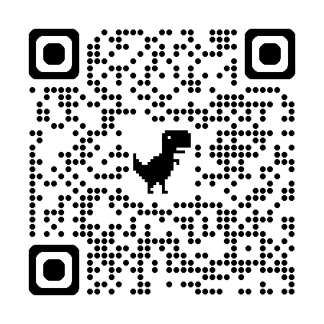

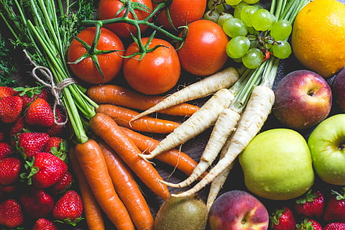

ALL FOOD OFFERED MUST BE TAKEN

??? email sturnquist@hancock.k12.mi.us

USDA is an equal opportunity provider and employer