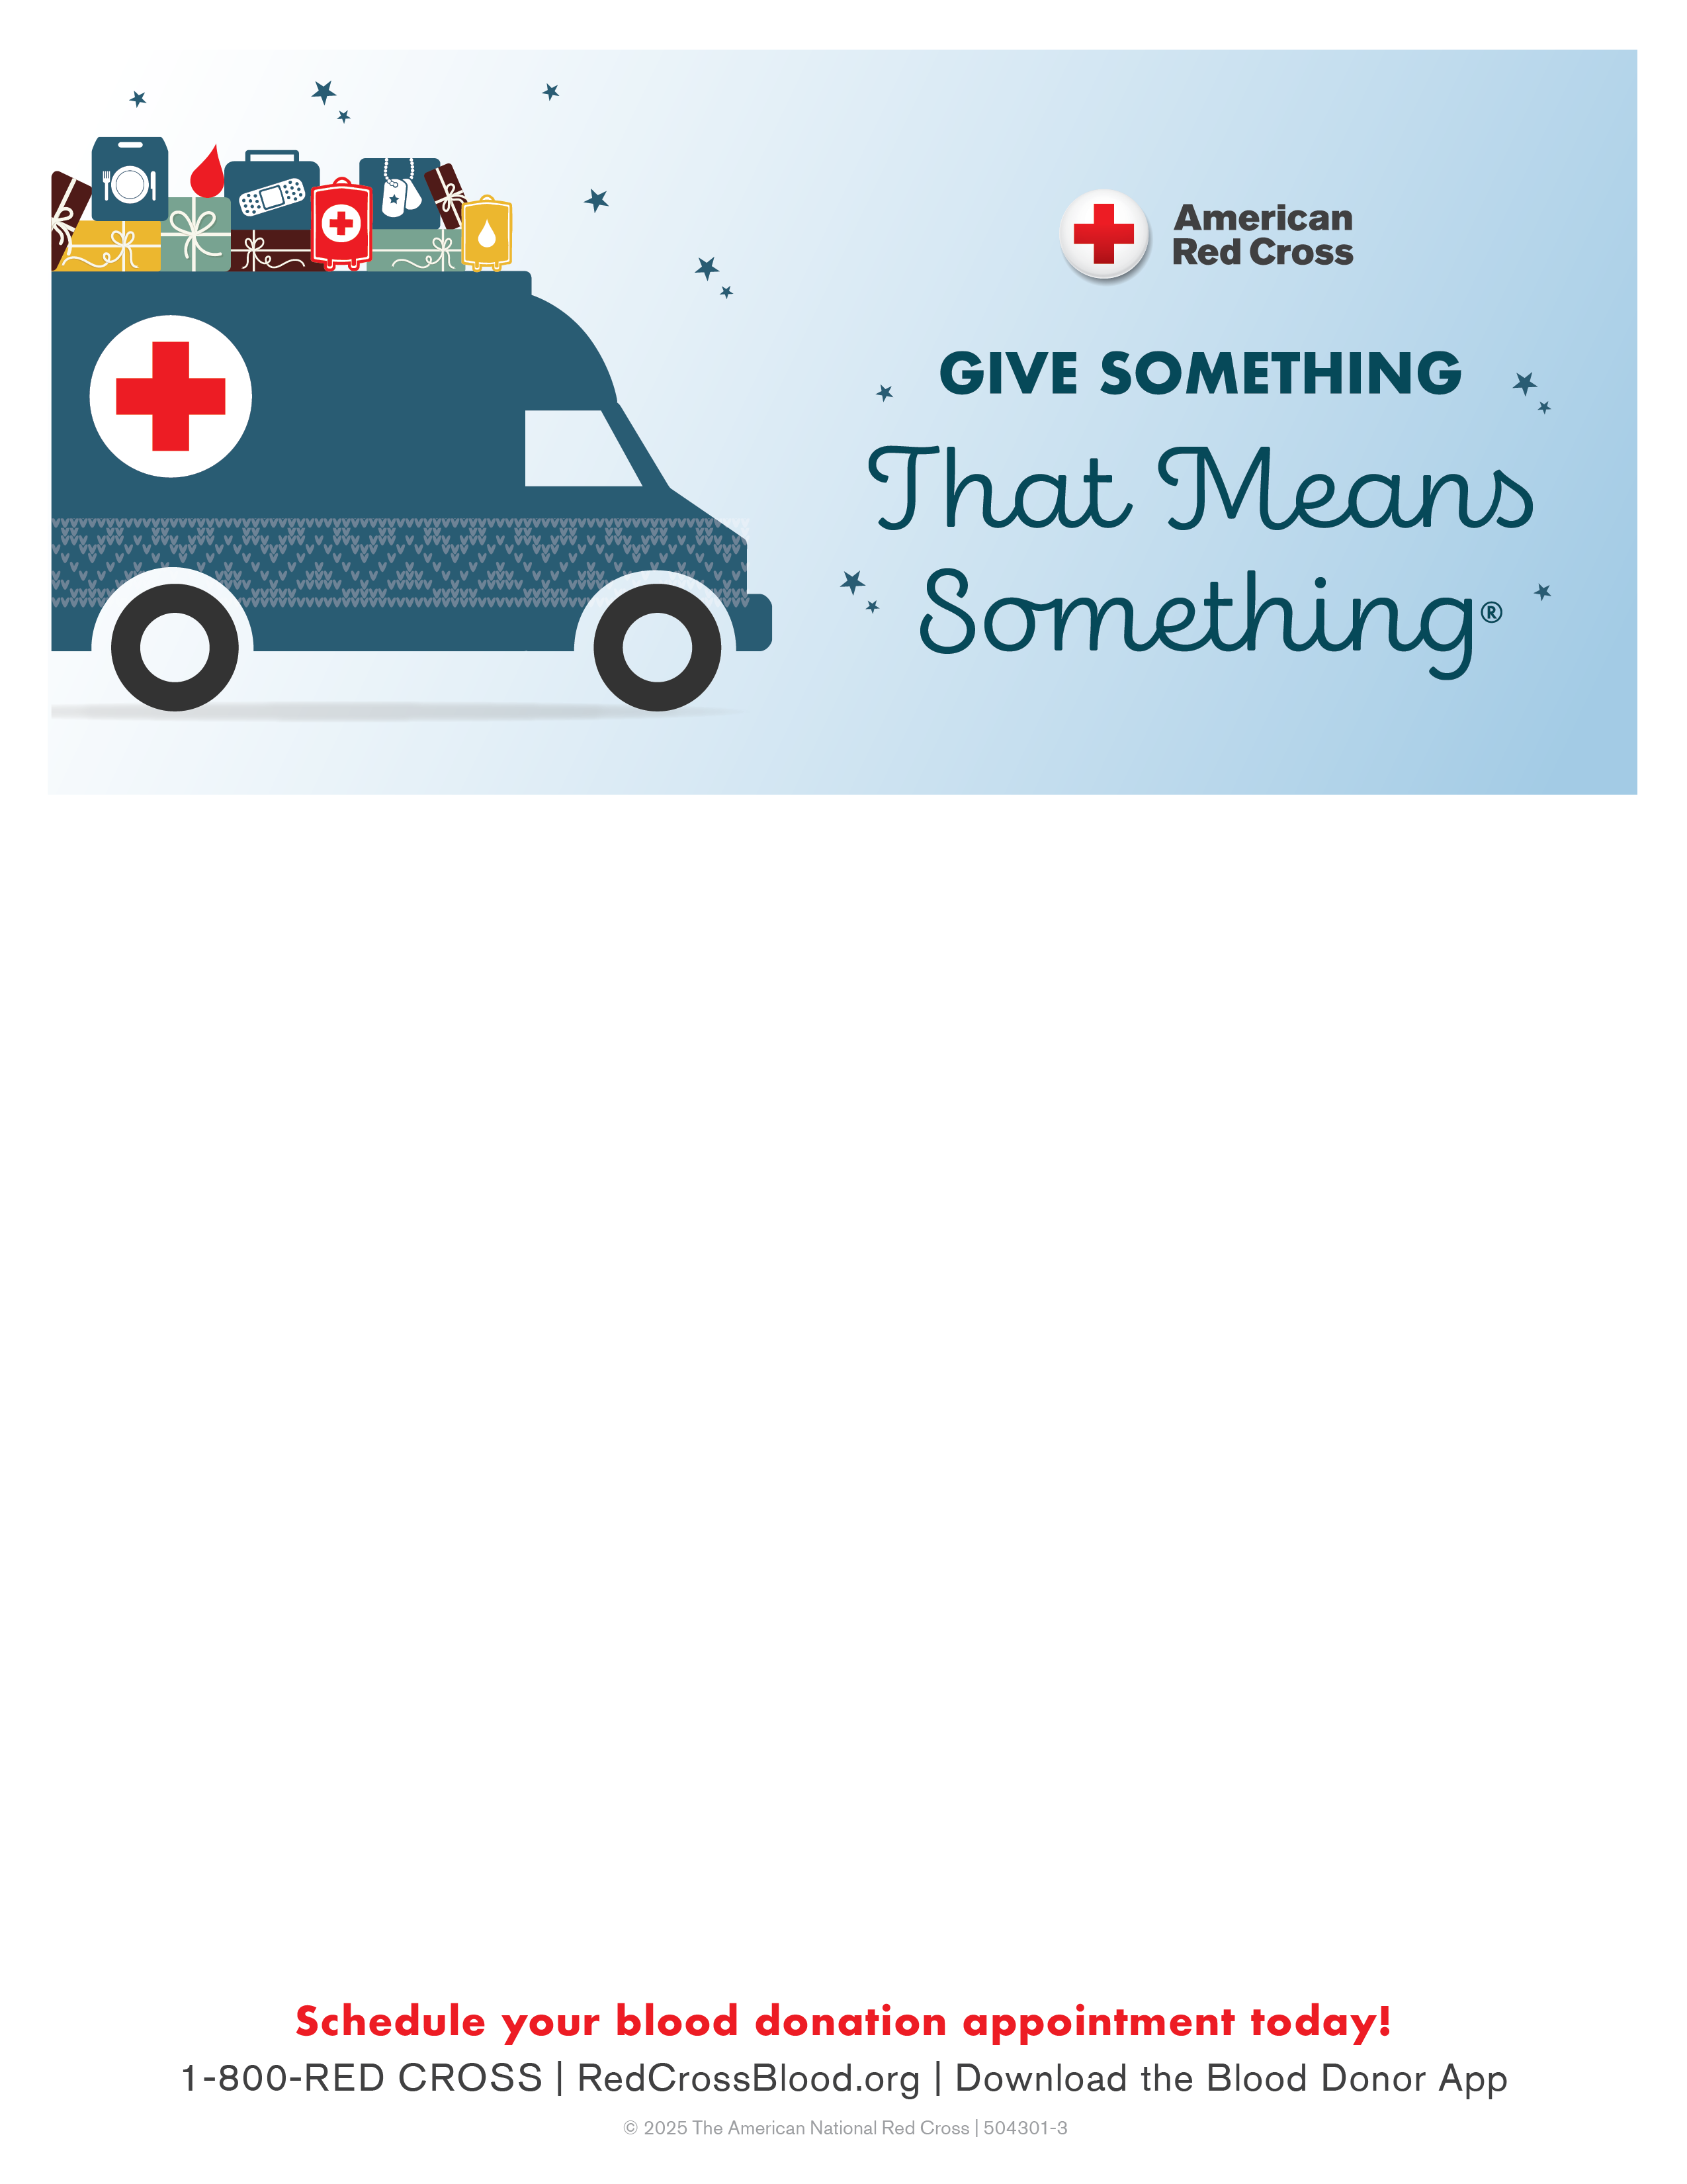
Green Bay Holiday Drives
December 23rd-Ashwaubenon Community Center
10am-3pm
900 Anderson Drive, Green Bay
December 24th-Howard Village Hall
7am-12pm
2456 Glendale Ave, Green Bay
Come give blood Dec. 19-Jan. 4 and get an exclusive long-sleeved Red Cross T-shirt, ltd. qty!
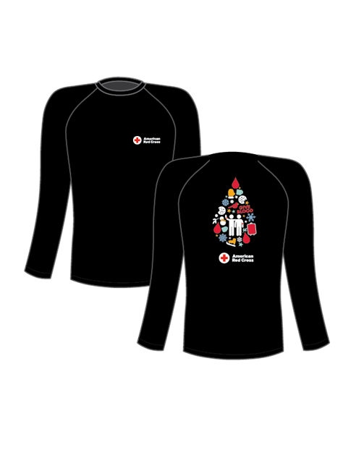
Sponsor Code: GBHolidayDrive
