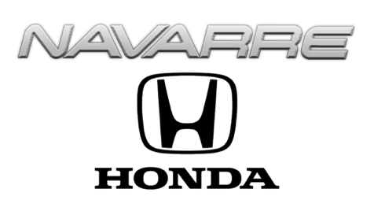

WIN A HONDA CIVIC HATCHBACK FROM NAVARRE
AND SO MUCH MORE!

Honda Contest Rules and Winner Obligations

- Eligibility Requirements: Participants must typically be legal U.S. residents, at least 18 years of age.
- Participants must have a valid driver's license and insurance.
- Employees of the Navarre Auto Group and their immediate family members are not eligible to win.
- No Media Employee participating in the Honda Giveaway nor their family members are eligible to win.
- No Purchase Necessary: Simply guess how many items are packed in the Honda Civic Hatchback. The closest guess wins all the prizes in the vehicle PLUS the Honda Civic!
- Taxes are the Winner's Responsibility: The winner is solely responsible for all federal, state, and local taxes on the value of this Honda Civic. The sticker price of this Honda Civic Hatchback is TWENTY-NINE THOUSAND THREE HUNDRED SEVENTY DOLLARS and no cents ($29,370) and is considered taxable income. Winner will receive an IRS Form 1099 and must pay these taxes before they can take possession of the vehicle.
- Other Fees: The winner is also responsible for registration, title, and license fees.
- Publicity Release: By entering, participants agree to allow Navarre Honda to use their name, likeness, and image for promotional and advertising purposes without further compensation.
- Prize Acceptance: Prizes are non-assignable and non-transferable, and no cash substitutions are allowed. Winners must claim their prize within one week or risk forfeiture.
- In case of a tie a drawing will be held to determine the winner.
- Listeners have until 4:00 PM on MARCH 4, 2026 to enter their best guess. Winner will be contacted after 5:00 PM on the same day.

