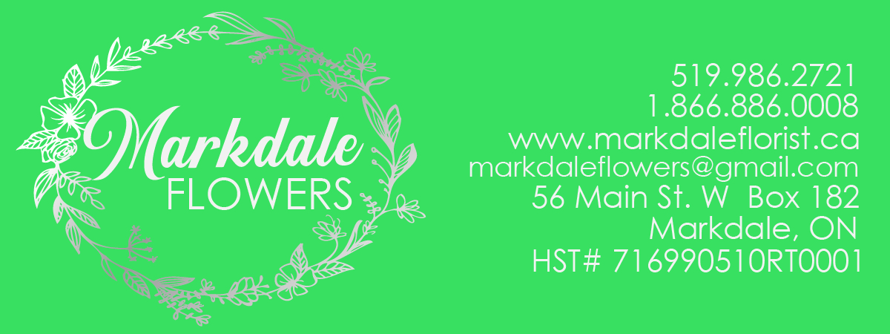Rental Items Available
Votive Candle holders (assortment of styles) $0.50 each
Rose Bowls $0.75 each
Round 10” Mirror $1.50 each
Square Mirror $1.50 each
Octagon 12” Mirror $2.50 each
Beveled Round 12” Mirror $2.50 each
Cylinder Set of 3 different height of vases $3.00 / set
Square or round inserts for the vases $0.50 each
Crystal bead rings- 45 inches $2.00 each
Tall glass vases – 3 different styles available $10.00 each
Bling buckle $0. 25 each
Gold Charger Plates $1.00 each
Silver Charger Plates $1.00 each
Black Charger Plates $1.00 each
Crystal Card box, wooden card box $20.00 each
Dimmer switch $10.50 each
Lawn Stork is Girl/ Boy $35.00 each
Projector Screen $35.00 each
Easel Floor model Steel $20.00 each
Lanterns Large (different styles available) $8.00 each
Lanterns Medium $6.00 each
Lanterns Small $3.00 each
Metal archway without décor $25.00 each
Seating chart frames available (few different styles) $10.00 Each
Apple creates $4.00 each
Wagon wheel bench (must be delivered) $10.00 Each
Chandelier – Crystal long $15.00
Chandelier - 3 candle white chandelier $15.00
Garden Hooks $1.00 each
Small marquee letters (Mr. & Mrs., BAR, LOVE, I DO) $20.00 each
Wooden ladders $20.00 each
Added shelves to the ladders $2.00 each
4- 7 Tier clear cupcake stand $35.00 each
3 clear bases for different height for candy bar or dessert table $15.00 each
Crystal cake stand $25.00 each
Candy bar set – LOVE dishes, an assortment of other containers to put candy and treats into.
No scoops available. $20.00 each
Sequence Table clothes and runners – Available indifferent colors – Gold, rose gold, silver, pink, purple, blush, and blush and white. Not all items available in all sizes.
90x90 Sequence $12.00 each
Runner Sequence $10.00 each
72X 144 oversized sequence tablecloths $18.00 each
8ft back drop sections $50.00 each
8ft back drop light sections $50.00 each
Other items available but must be delivered and set up. Please contact for pricing of these items.
Marquee letters – MR & MRS (3ft), 4 ft LOVE, 2 ft LOVE, Heart
Backdrops in White, cream, black and a mix of other types of fabrics
Archways – Cedar rail archway, Wooden archway, Hexagon archway, metal archway with décor included.
Urn & pillars – Ceramic looking urns with matching pillars, cedar pillars that can be used as planter too.
Check out our Facebook & Instagram pages Markdale Flowers and Kimberley’s Country Flowers and Wedding décor.

