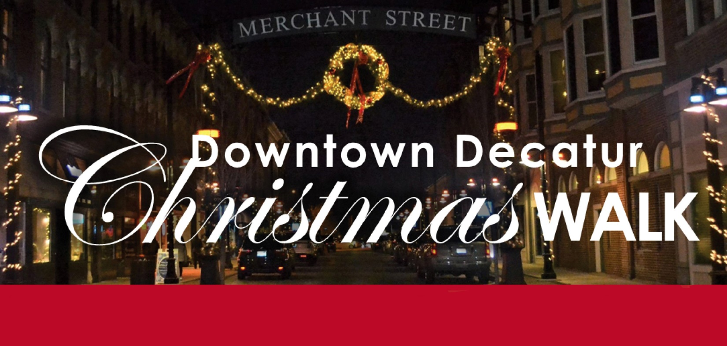

**Download this document here ->**

Wednesday, December 4 – 5-8 pm

Bring the family to welcome the holiday season and enjoy holiday treats, music, activities, and SHOPPING!

* Free trolley throughout downtown. (On back)
* Santa Claus in the Transfer House.

**Here’s some of what you’ll find:**

* Throughout downtown
  + Debbie’s Dance Studio Dancers
* Central Park
  + 5:15-6:15 pm – Caroling with Opus 24
  + 6:30-7:30 pm – Caroling with Opus 24
  + Giant lighted ornament photo-op
* All Things Beautiful / I Meditate Crystals N Candles by Kia
  + DJ on the sidewalk
  + In-store specials
* Blue Connection
  + Holiday treats
* Decatur Area Arts Council
  + 5:15-6:15 pm – Caroling with Opus 24
  + 6:30-7:30 pm – Caroling with Opus 24
  + Holiday treats
* Decatur Brew Works
  + 7-9 pm – Broken Brogue and special guest
* Decatur Civic Center
  + 5:45 pm – Santa letter-writing station
  + 6 pm – Christmas Tree Lighting
  + 6-7:30 pm – Live holiday music
  + 6-8 pm – Live Reindeer
  + 6:30-7:30 pm – Free family ice skating
  + Hot cocoa and mini doughnut truck
* Decatur Public Library
  + 4:30-6 pm – Games and crafts for kids
* Donnie’s Homespun Pizza
  + Pizza slices and hot chocolate bar
* GK9 Wine & Spirits
  + Charcuterie snacks for purchase
* Hickory Point Bank
  + 5-6 pm – French Horn Group
  + 6-7 pm – Second Wind Flute Choir
  + Costumed characters
  + Holiday treats
* Lincoln Square Theater
  + Live holiday music
  + BBQ Food Truck
* Merchant Street / Giggles / Cass Concepts
  + Street will be closed to traffic
  + DJ Dance Party
  + Costumed characters
  + Reindeer Games
  + Holiday treats
  + Caroling with Our Lady of Lourdes kids
* Merle Norman Cosmetics
  + Hot cocoa and other treats
  + In-store specials
  + Drawing
* Preston Jackson Park
  + Christmas Card Lane
* Shop On Main / Party Shop
  + In-store specials
  + Holiday treats
* Thinkwell Makerspace (120 N. Franklin)
  + Holiday button making
  + Tech demonstrations
  + Public Pixel Painting project
  + 5:30-7:30 pm – Decatur Youth Symphony Orchestra