2025 State Football Finals
University of South Dakota – DakotaDome
November 13, 14 & 15

General Team Information

Congratulations to your school for qualifying for the State Football Semifinals. The attached document contains information pertinent to our upcoming championship games; should you have any questions, feel free to contact me directly.

TOURNAMENT DIRECTOR:
Randy Soma, Asst. Executive Director, SDHSAA
605-651-2440
randy.soma@sdhsaa.com

TOURNAMENT HEADQUARTERS:
Tournament Headquarters will be located within the SDHSAA Suite on the west side of the Dakota Dome. Contact Randy Soma as above for location information.

TICKETING:

Friday Evening:
  - Semifinal contests are played across the state. Following the conclusion of those semifinal contests, an email will be sent to the Superintendent ,Athletic Director and Head Football Coaches of each qualifying school.
  - Team “sidelines” will be determined, and the designated student section will be on the South end of each sideline.

Saturday 8:00 AM

  - Tickets for the South Dakota High School Football Championships will go on sale on Saturday, November 8th at 8:00 a.m. on GoYotes.com/Tickets.

Monday, 9:00 AM
  - All remaining tickets will be “On Sale” to the general public

Ticket Prices: They will remain $15.00 for Adult Seating, $10.00 for student seats located in the designated “student section”. For any other questions, the ticket office will be available for emails at tickets@usd.edu. They will respond to emails as quickly as They can. There will be a service charge of $3.00 for all online orders. Tickets can also be purchased through the ticket office on Monday morning starting at 9:00am by calling 605-677-5959.

Suites/Loge: They will be available for Championship contests. Interested parties can contact the USD Ticket Office to be placed on a “call list.” Once USD Season Ticket Holders have exercised their option to potentially rent their suite for any/all championship games, members of the general public will have the opportunity to rent a suite for the game(s) of their choice. Please see the attachment on USD Loge & Suite Info

TEAM DESIGNATIONS, LOCKER ROOMS & UNIFORM COLORS (Updated 2021):
In each match-up, the team that qualified with the higher point average for the playoffs will be designated as the HOME team and shall wear their DARK uniforms. The designated VISITING team shall wear their WHITE uniforms.

Class | Home Team | Sideline | Visiting Team | Sideline
9B | St. Mary’s | WEST | Avon | EAST
9A | Wall | WEST | Howard | EAST
9AA | Freeman/Marion/Freeman Academy | WEST | Elkton-Lake Benton | EAST
11B | Elk Point-Jefferson | WEST | St. Thomas More | EAST
11A | Sioux Falls Christian | WEST | Lennox | EAST
11AA | Yankton | WEST | Pierre T.F. Riggs | EAST
11AAA | Brandon Valley | WEST | Sioux Falls Lincoln | EAST

A representative from the SDHSAA or USD will be at the field level to direct teams, students, parents and administrators to the appropriate areas on the day of your game. This will include Press Box, Filming, Locker Room and other designated areas.

Locker-Rooms

Class | Home Team | Locker Room | Sideline | Visiting Team | Locker Room | Sideline
9B | St. Mary’s | A | WEST | Avon | E | EAST
9AA | Freeman/Marion/Freeman Academy | B | WEST | Elkton-Lake Benton | D | EAST
9A | Wall | B | WEST | Howard | D | EAST
11B | Elk Point-Jefferson | A | WEST | St. Thomas More | E | EAST
11AA | Yankton | B | WEST | Pierre T.F. Riggs | D | EAST
11A | Sioux Falls Christian | A | WEST | Lennox | E | EAST
11AAA | Brandon Valley | B | WEST | Sioux Falls Lincoln | D | EAST

GAME MATCH-UPS, OFFICIALS & DESIGNATIONS:
Thursday, November 13
11:00 AM Kickoff (Intros at 10:54) | 9B
7:00 PM Kickoff (Intros at 6:54) | 9AA
Friday, November 14
10:00 AM Kickoff (Intros at 9:54) | 9A
2:00 PM Kickoff (Intros at 1:54) | 11B
7:00 PM Kickoff (Intros at 6:54) | 11AA
Saturday, November 15
12:00 PM Kickoff (Intros at 11:54) | 11A
5:00 PM Kickoff (Intros at 4:54) | 11AAA

ADMINISTRATOR ARRIVAL AT DAKOTADOME:
Admission Passes and Sideline Credentials will be made available for your team and coaching staff in the Tournament Headquarters beginning two hours prior to each contest. Each school must have an administrator stop by Headquarters prior to your team’s arrival (or make alternate arrangements with Randy Soma in advance) to pick up your team packet. At this meeting, school admin will:
- Pick-up of sideline passes for team personnel
  - Teams will receive 1 pass per coach, trainer, manager, statistician, and bus driver(s). This list will be taken off the roster on the website on Monday November 10 at Noon. Teams will receive 8 additional administration passes for the session they play at.
  - Side-line passes will be issued as requested for official team personnel. ONLY AUTHORIZED PERSONNEL will be given sideline passes; only those with sideline passes will be allowed on the field level during contests.
  - Cheerleaders will be allowed on the sideline. We will only issue 8 cheerleader passes per squad, plus 1 Mascot and 1 advisor. All others will have to purchase tickets at the site. They must be listed on the roster. Cheerleaders will have a dressing room and can be found on the map below.
  - All schools that qualify for the State Championships are required to have on-site crowd and cheer team (if applicable) supervision during their game. Cheerleader Supervision and Crowd Supervision forms need to be filled out by Monday, November 10 by Noon. This form is located under your account in the custom forms area and is labeled Football – State Championship Supervision.

TEAM ARRIVAL AT THE DAKOTADOME:
Teams are asked to enter on the WEST side of the Dakota Dome. A designated loading zone will be made available on the NORTHWEST loading area of the Dome (See attached parking map). Buses are to be parked in Walmart Parking lot after drop-off. We will have a shuttle for the bus driver.

Teams will be contacted by a “host” individual from Vermillion with more information on assistance on your arrival. Team members must remain off the playing surface until the start of their allotted warm-up period.

TEAMS WILL NOT BE ALLOWED INTO THE DAKOTA DOME UNTIL 2 HOURS PRIOR TO THEIR POSTED GAME TIME. Please do not show up early!

ADULT/STUDENT SECTIONS:
As noted above, seating areas have been determined following semifinal play. It is the responsibility of member schools to provide ample supervision for the Adult and Student Sections. Student Sections – Visitors Section C, Home Section P
NOTE: USD and the SDHSAA are selling premium ticketing options for Loge and Suite seating. Each of those areas are located on the West side of the stadium, but open to anyone to purchase throughout the weekend. (See other attachment)

GAME BALLS:
The SDHSAA will furnish sufficient Big Game Team Issued game balls for play in all games. However, should a team wish to use its own game balls, they may do so provided:
- A minimum of three game balls are available
- Game balls are deemed legal by the officiating crew for your contest

TURF PROHIBITIONS:
Due to the field-turf surface, the following prohibitions are in effect for teams entering the stadium:
- All on-field personnel (players, coaches, ball-boys, stats, managers, etc.) are prohibited from use of sunflower seeds, chewing gum or bubble gum on the sidelines. As always, chewing tobacco is also not allowed to be used during a high school event.
- Teams are allowed to bring in their own water bottles but cannot bring in any Powerade/Gatorade/etc. as it will stain the turf.

SDPB INTERVIEWS:
As all games are being broadcast by South Dakota Public Broadcasting, coaches may be approached to conduct an on-camera interview either before, after or during halftime of your contest. Please comply with this request from SDPB, if given.

WARM-UPS, PLAYER INTRODUCTIONS & NATIONAL ANTHEM:
TEAMS WHOSE SIDELINES ARE ON THE WEST SIDE OF THE DOME WILL WARMUP ON THE NORTH HALF OF THE FIELD. TEAMS WHOSE SIDELINES ARE ON THE EAST SIDE OF THE DOME WILL WARMUP ON THE SOUTH HALF OF THE FIELD.

Team members will not be allowed onto the playing surface of the DakotaDome for full football activities until at most SIXTY MINUTES prior to kick-off. Stretching or light calisthenics is allowable, but no formal warm-ups may take place until SIXTY MINUTES prior to game time.

For 11B & 11AAA contests, a minimum of TWENTY minutes of on-field warm-up time will be given as they are following another contest on the game field.

In coordination with South Dakota Public Broadcasting, the clock for warm-ups will expire six minutes prior to the posted game time (10:54 for an 11:00 game time, for example).

An approximate itinerary of each game’s events is as follows:
- 66 minutes prior to posted game time – warm-ups begin with 60:00 on the game clock
- At 30:00 on the game clock – officials meet with coaches (or earliest opportunity if less than 30 is posted for pregame warmup)
- At 2:00 on the game clock – teams retreat to their respective sidelines
- At 0:00 on the game clock
  - Introductions –
    - Visiting Cheerleaders
    - Home Cheerleaders
    - Visiting Defensive Starters
    - Home Offensive Starters
    - Officials
  - The National Anthem will be played/sung/performed (first game of each session) at 11am and 7pm on Thursday. 10am and 7pm on Friday and 12pm and 5pm on Saturday)
  - Officials will accompany team captains to the coin-toss
  - The coin-toss will be conducted at midfield simultaneously with a presentation of the game ball from the SD Army National Guard.
  - Kickoff!
“TV” TIME-OUTS:
With the games being broadcast live, one additional time-out will be called per quarter by the Referee. This time-out should be treated much as a team time-out administratively. The TV Time-Out will be taken following the first change of possession in each quarter that takes place with under seven minutes to go in that quarter. A charged, team timeout will not take the place of this TV Timeout in any circumstance.

HALF TIME:
Halftime will be set for 15-plus-3 minutes for ALL CONTESTS. If halftime awards or entertainment run long, no penalty will be assessed to either team as long as they are present on the field prior to the “additional” three minutes beginning.

FILMING:
Designated filming areas will be available for teams in the USD press box. Telescopic end zone cameras are not permitted. Any Hudl equipment other than cameras should be set up in the corners of the end zones, outside of the team bench areas.

ATHLETIC TRAINING:
The auxiliary athletic training room on the east side of the dome will serve as the primary
athletic training room during the event. USD will provide coolers, cups, water and ice. Schools
must provide their own water bottles.

AWARDS CEREMONY & POST-GAME PROTOCOL:

Immediately following the contest, awards will be presented to the Runner-Up and Championship teams. Individual MVP awards will also be presented following the team awards.
A representative from either SDPB or SDHSAA will direct each team through this process, with the following order to be followed: Fans will not be allowed on to the playing surface at the stadium and, encouraged to leave the facility following the conclusion of their contest.

- Presentation of Awards
  - Representatives of each team are to come forward to receive awards as called.
    - A maximum number of medals will be provided for teams (41 for 9-man, 51 for 11-man). Schools wishing to obtain additional medals may do so for a fee through the SDHSAA office following the State Championships
  - Individual awards will be issued to those chosen by the respective organizations
- Team Picture
  - Teams are to immediately proceed to a designated area in front of their endzone sections for a team picture, win or lose
- Post-Game Interview
  - Selected Team members, including the Head Coach, will be asked to proceed to a designated area for a post-game interview with SDPB
  - No other interviews are to be given until the conclusion of the SDPB Post-Game interview(s)

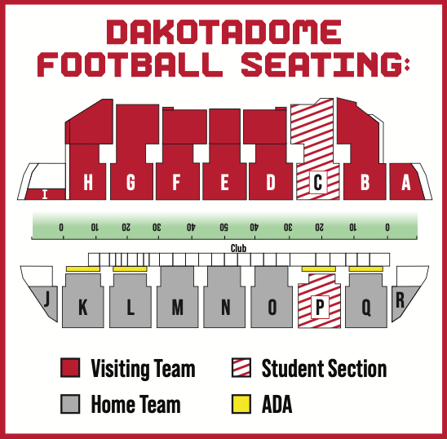
ALL SEATS ARE GENERAL ADMISSION
Ticket Prices:
Tickets for the South Dakota High School Football Championships will go on-sale on Monday, November 10th at 9:00 a.m. on GoYotes.com/Tickets you may also purchase over the phone at 605-677-5959 starting on Monday November 10th at 9:00 a.m.
Student Sections will be “C” & “P”
$15.00 for Adults
$10.00 for students
There will be a service charge of $3.00 for all online orders.

Suites/Loge:
Suites and Loges are also available to purchase. Suites are $750 and Loges are $500 per session. Please contact the Coyote Ticket Office at 605-677-5959 or email us at tickets@usd.edu for more information.

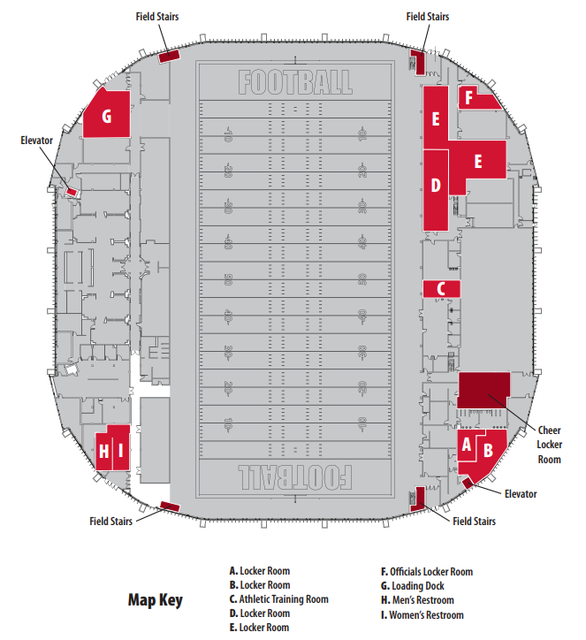
Visiting Team Warm-up
Home Team Warm-up
Home Team Sideline
Visiting Team Sideline
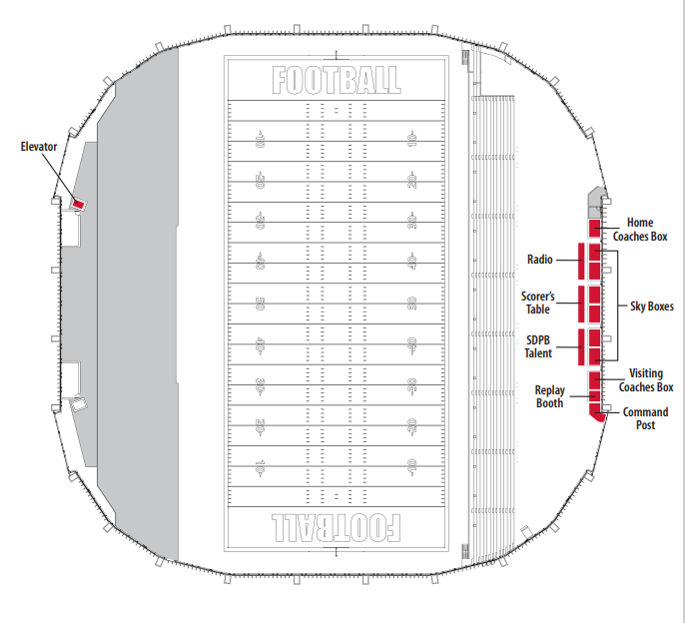

Suite/Loge Use at South Dakota High School Football Championships
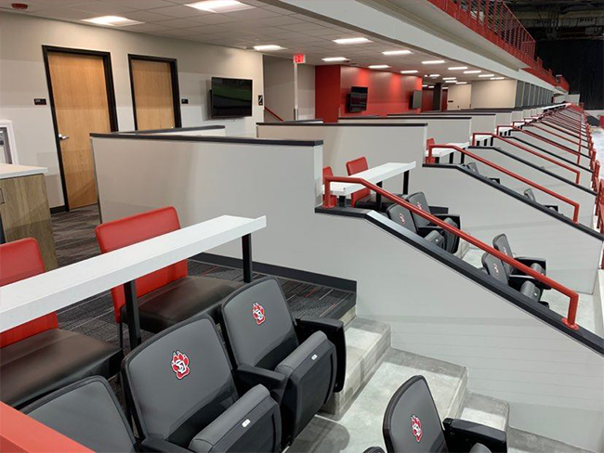
Congratulations on a terrific football season and we can't wait to see you in the Dakota Dome! We are excited to offer you access to open suite or loge boxes at the South Dakota High School Football Championships. Shown in the photo above, these are exclusive premium seating areas located just above the west sideline. We are offering you access to all seven South Dakota High School Football Championship games played inside the Dakota Dôme. Please share this offer with your community. They can reach out to the Coyote Ticket office to reserve their spot. The schedule of games is as follows:
- Thursday, November 14
  - Session 1
    - 9B Championship 11:00 a.m.
  - Session 2
    - 9AA Championship 7:00 p.m.
- Friday, November 15
  - Session 3
    - 9A Championship 10:00 a.m.
    - 11B Championship 2:00 p.m.
  - Session 4
    - 11AA Championship 7:00 p.m.
- Saturday, November 16
  - Session 5
    - 11A Championship 12:00 p.m.
    - 11AAA Championship 5:00 p.m.
If this opportunity interests you or anyone in your community, please see the steps below on how you can reserve a suite or loge:
- Step 1: Contact the ticket office to reserve your Suite or Loge
  - Please contact the Coyote Ticket Office at tickets@usd.edu, by Tuesday, November 11th at noon Please indicate your contact information, which games you would like to reserve the suite or loge for and how many people will be accompanying you.
  - Suites have 12 seats and are available at $750 per session, while Loge Boxes have 8 seats are available at $500 per session.
  - You will be seated on a first-to-reserve basis.
- Step 2: Come to the game
  - Enter through the west side of the Dakota Dome and proceed to the Club Level entrances located near the concessions stands. There is also an elevator on the west side near the north entrance.
  - Food and beverages can be purchased from the Dakota Dome concession stands and brought to the suite or loge. No outside food or beverage is allowed. Again, congratulations on a wonderful season. We're excited to host you soon. Please contact the Coyote Ticket Office at tickets@usd.edu with any question.

Parking Information – University of South Dakota
- This is a USD fee, and all proceeds go directly to the University of South Dakota. The SDHSAA does not collect any portion of this fee. For questions please contact USD at https://goyotes.com/tickets.
- Yellow Lots: Parking in the yellow-marked lots will require a $5.00 fee per vehicle. Please note: USD will only accept cash for these lots.
- Green Lots: These are general parking areas and are free of charge.
- Student Parking: High school students may park for free by showing a school-issued student ID. If a school does not provide IDs, students can simply state that they are a high school student.
- ADA Parking: Vehicles must display a valid handicap permit to park in designated ADA spaces.
