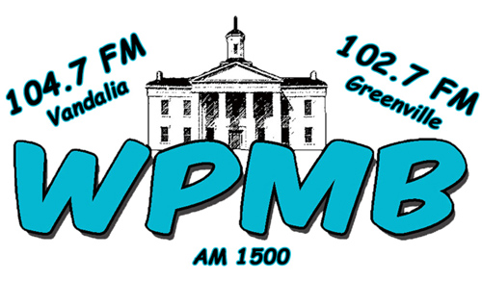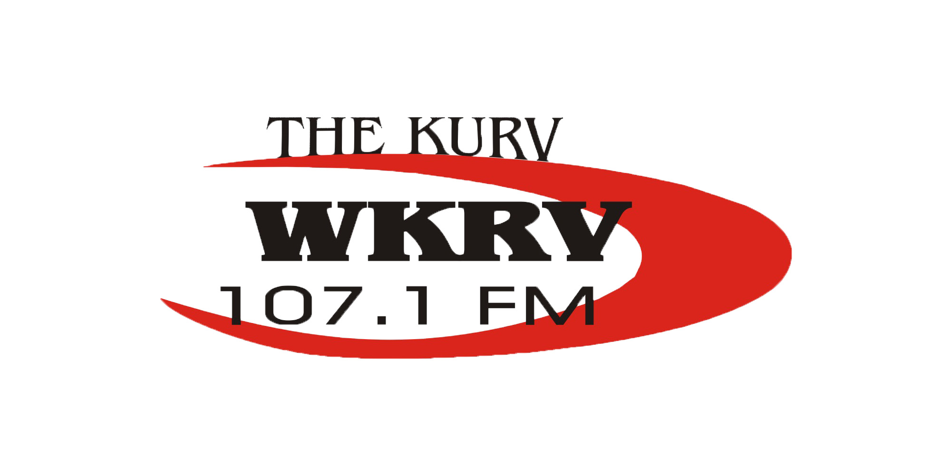

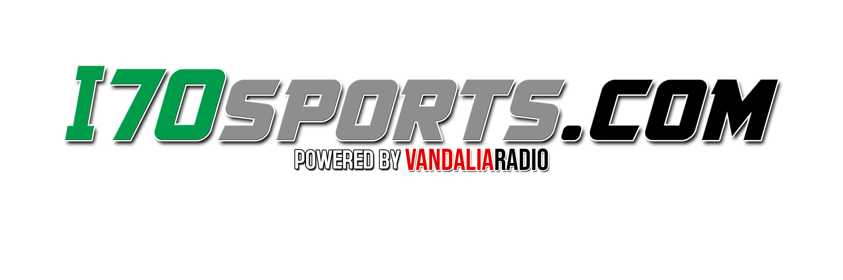

**__________________________________________________________________________**

232 S. 4th Street, Vandalia, IL 62471 618-283-2325 [www.vandaliaradio.com](http://www.vandaliaradio.com/) [www.i70sports.com](http://www.i70sports.com/)

**__________________________________________________________________________**

**Vandals Football on 107.1 FM WKRV & www.vandaliaradio.com**

For the 7th year in a row, Vandals football has made the playoffs. The Vandals will play at Lawrenceville on Saturday afternoon at 2 pm in Round 1 of the playoffs.

**Special Sponsor**--- As a special sponsor, you will receive two commercials during the game along with billboard mentions before and after the game. You will also get an extra commercial and live mentions as a special sponsor.

**Total Commitment**: $100 for October and you then remain a sponsor for as long as the Vandals are playing.

**Basic Sponsor**---You will receive a commercial during the game along with billboard mentions before and after the game.

**Total Commitment:** $50 for October and you then remain a sponsor for as long as the Vandals are playing.

This time order represents confirmation of the agreement between Agency/Advertiser and station and is subject to all terms and conditions of AAAA standard contract (and of the master agreement where signed between agency and station). Station agrees to hold and save Agency/Advertiser harmless against all liability resulting from the broadcast of (1) program material except program material furnished by Agency, (2) musical compositions licensed for broadcast by a music licensing organization of which station is a licensee. Agency/Advertiser agrees to hold and save station harmless against all liability except musical compositions licensed as stated above. TERMS: Bills are payable within 10 days after date of our Invoice date. Overdue accounts will be subject to a finance charge at the rate of 1 1/2% per month. Advertiser agrees to pay costs of collection including attorney's fees on accounts overdue. The undersigned personally guarantees, unconditionally and at all times, the payment when due of any and all indebtedness of Agency/Advertiser to the station.

------------------------------------ -----------------------------------------

Authorized Buyer Station Representative